**Guided Capstone Project**

Based on the data provided of 330 Mountain Resort across the USA, the Adult ticket price for the weekend for the Big Mountain Resort is underpriced.

According to the model (Random Forest Algorithm), a Big Mountain resort can accommodate the price from the current $81 up to the modeled $94.22 price. It is more than $10 per ticket. This would significantly increase the revenue of the Big mountain resort assuming the number of visitors would be 350,000 over the season and visitors ski on an average for 5 days from $7 M (+$4/ticket) to $21M(+$12/ticket).

Out Of the 32 features evaluated in the study, 6 key features impacted ticket prices the most, in order of impact: Fast Quads, Runs, Snowmaking, Vertical Drop, Skiable Terrain, and Total Chairs. These features were used for the recommendations for the next steps.

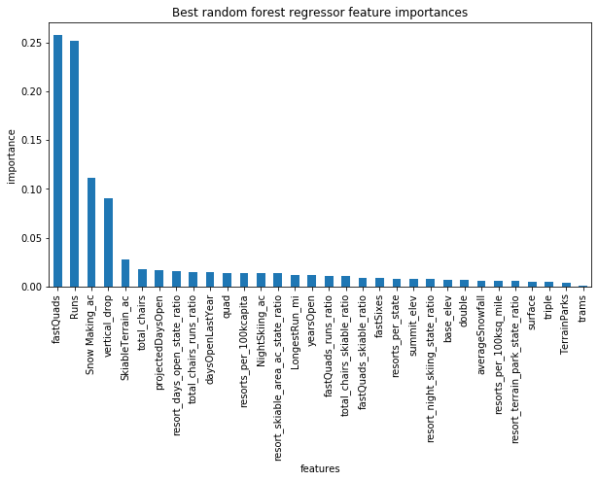

**Recommendations:**

* Firstly, Increase Adult ticket price from the current $81 to $86 per day per customer based on the existing features provided by the Resort. This would increase revenue (+6.2%). Based on the positive results above, increase ticket prices can be increased up to $94.
* Permanently close one run which one is least used by visitors. Based on the study, It should not impact the price.
* The resort can also increase the runs by 1, vertical drop by 150, and total chairs by 1 to accommodate more $2 increase in price.
* The study shows that FastQuad is the most impacting feature on the price. So, if the resort adds one more FastQuad, the resort can bear an increased price of an additional $23 per ticket. However, there would be an additional cost to add a new FastQuad which needed to be considered before implementing this change.
* Another major impacting feature is the snowmaking area. Study shows that if the resort increases the snowmaking area up to 21 acres, there is not a change in the price. Moreover, from 21-52 acres increase in snowmaking area just supports an increase of $1 per ticket for the price. So, if a resort planning to increase the snowmaking area to 50 acres, might have increased to 54 acres which can bear an increased price of $4.5 per ticket.
* The study shows indicates that the increase in vertical drop by 363 feet would accommodate an increased price of $6 per ticket.
* There is also no impact on the price by decreasing the skiable terrain area by 248 acres. So the resort can also do that to decrease the operation cost.